

Theremino DAA

Version 3.0

Instructions

www.theremino.com/en

www.theremino.com/en/downloads/uncategorized#daa

The Digital Audio Analyzer

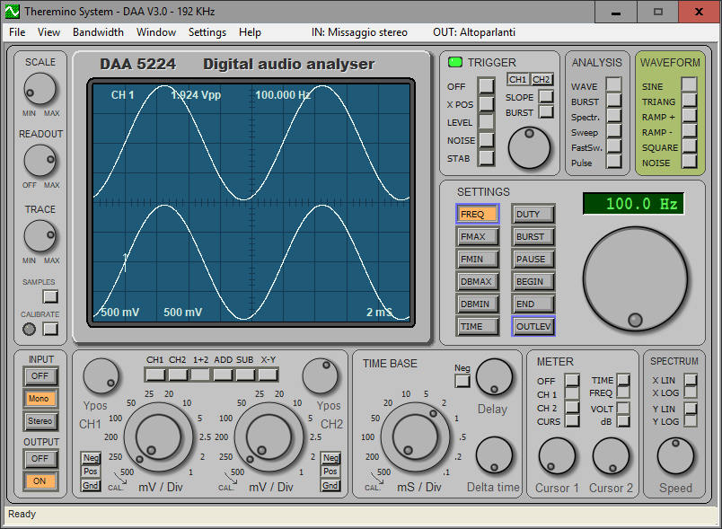

The DAA is a measuring and testing instrument for sound equipments.

Like all the theremino system applications, the DAA is also a "portable" application. The "portable" applications do not require installation and do not modify anything outside the folder in which they are located. It is therefore possible to copy them from one folder to another or from one computer to another.

With the "portable" applications the operating system is not modified and the installation and uninstallation operations are simplified.

Install
Copy "Daa.exe" and the documentation folder “Docs” in any folder. Then start the file "Daa.exe".

Uninstall
Delete all the DAA files.

The Display Commands panel

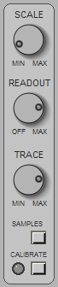

SCALE Adjust the brightness of the grid (grid of the display)

READOUT Adjust the brightness of a display.

TRACE Adjust the brightness of the trace on the display.

SAMPLES View the samples used by Spectrum, Sweep and Pulse FastSweep

CALIBRATE Make calibration operations

Notes for the SAMPLES command

View the samples on which the analysis of the spectrum is done.

When making "Spectrum" type analysis. "Sweep", "FastSweep" and "Pulse" it is good to press this button and check the amplitude in volts of the signals that need to be wide as much as possible (act on the amplifier volume of Outlevel and the system mixer) but which must not reach more than one volt in a positive or negative with respect to zero.

If the signals amplitude is low there will be too much noise that will disturb the measurements, if it reaches the volt signals will be truncated and the measurement will be distorted.

Notes for the CALIBRATE command

The sampling hardware can generate an imbalance of the signal with respect to zero, to highlight:
- Press the STEREO button
- Ensure that the type is WAVE ANALYSIS
- Select channels 1 + 2 on CHANNEL SELECTION OF KEYBOARD
- Make sure that the MIXER registration inputs are all zero
Raising now knob mV / Div of channel 1 up to the maximum of 1 mV (turn the outer part) you will see the trace move up or down.

Raising the knob mV / Div of channel 2 is highlighted the moving channel 2. The displacement of the track is due to an imbalance of the converter of the sampling card AD and does not disturb the normal operation of the card, but, in order to obtain precise measurements, it must be correct.

Correct the unbalance with “Calibrate”

To make an imbalance correction make sure the keyboard is in the STEREO INPUT, the ANALYZES OF WAVE is and that the MIXER sliders are all lowered to zero, press the CALIBRATE button and wait a few seconds.

During calibration, the LEDs CALIBRATE must quickly flashing red (calibration of channel 1) and then quickly flash green (channel calibration 2) .

If the LED flashes red only means that the INPUT is MONO and the calibration has been performed only on channel 1.

If the LED does not blink at all means that there is the input signal (more than 3 mV peak-to-peak, make sure that the MIXER potentiometers are all set to zero and try again).

The calibration thus performed is saved on “DaaMainRegulations.ini” file and is automatically restored every time you start the DAA.

The calibration may become inaccurate if you change the registration inputs on the Mixer and can change over time for the natural aging of the hardware components.

If the TYPE OF ANALYSIS is SWEEP, FASTSWEEP, SPECTRUM PULSE or the calibration button assumes a different function, pressing it makes flat the response curve and then creates a reference on which to perform comparison measurements, the LED CALIBRATE becomes green and indicates that there is the reference calibration, by pressing the button again CALIBRATE the LED turns off and the reference calibration is disabled. If changing FMAX, FMIN, or TIME TYPE ANALYSIS the reference is no longer valid is then automatically disabled and the LED turns off.

The Input Output panel

This panel enables and disables the input and output of signals.

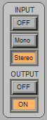

INPUT OFF
Disables sampling (the signal reading).

This command freezes what has been sampled and allows to analyze it for a long time (in this condition the displayed signals originate from an internal buffer that contains the last 10 seconds sampled).

INPUT MONO
It enables sampling for the only channel 1 (left).

The display functions which provide the channel 2 will use it for the channel 1 data.

INPUT STEREO
Enables independent sampling on two channels. (CH1 = Left / CH2 = right).

OUTPUT OFF
Disable the signal generator.

OUTPUT ON
Enable the signal generator.

The generated signal is chosen with the WAVEFORM panel and is adjusted in amplitude with SETTING - Outlevel.
The signal generator is MONO and sends the same signal on channels 1 and 2.

The CH1 and CH2 panel

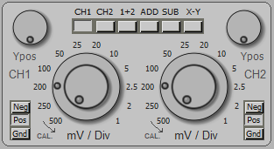

This panel is part of the Oscilloscope section and you only use with WAVE BURST and analysis.

The panel is composed by: a Keyboard for channel selections, two knobs mV/Div, two YPos knobs and two Neg/Pos/Gnd keyboards.

The knobs and keyboards are doubled (left and right) and act on channels 1 and 2.

CHANNEL SELECTION KEYBOARD

CH1 The channel 1.
CH2 The channel 2.
1+2 View channels 1 and 2 simultaneously.
ADD Show only one track which is the sum of channels 1 and 2.
SUB Show only one track which is the difference of channels 1 and 2.
XY The channel 1 in X and channel 2 in Y.

OTHER COMMANDS

YPOS Track Location.

mV/Div Select the scale in millivolts per division of the display grid.
The outer ring of twelve places select from 500 mV to 1 mV.
The potentiometer allows fine adjustment (turning left the value is indicated by the outer ring).
The millivolt per division are also displayed on the display, at the bottom left.

NEG The signal is vertically mirrored (useful for some audio cards).

POS The signal is not vertically mirrored.

GND Display track at zero for a reference.
In position GND signals are sampled equally, only the display is suppressed.

The Time Base panel

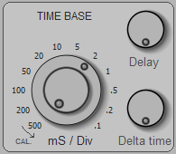
This panel is part of the Oscilloscope section is only used with the WAVE BURST and analysis.

mS / Div This knob determines the scanning speed.

The outer ring select twelve places from 500 mS to 0.1 mS.

The potentiometer allows fine adjustment (turning hard left the actual value It is indicated by the outer ring).

The milliseconds per division are also displayed on the display, at the bottom right.

DELAY It works only with INPUT - Off and allows you to move along the display window all the buffer sampled signals.

The zero corresponds to a total rotation in a clockwise direction.

If the DELAY knob is not zero its value is displayed on the display
(Bottom in central position) as: Dly xxx mS

DELTA TIME It works only with CHANNEL SELECTION in position 1+2, ADD, SUB and XY.

Move over time the channel 2 while maintaining the channel 1 fixed.

The zero corresponds to a total rotation in a clockwise direction.

If the DELTA TIME knob is not at zero its value is displayed on the display (in low in a central position) as: dT xxx mS

The Meter panel

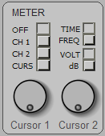

This panel is part of the Oscilloscope section is only used with the WAVE BURST and analysis.

OFF All measurements are disabled.

CH1 Continuous measurement of the channel 1.
On the top line of the display shows CH1, the peak-to-peak voltage in volts or in decibel (referenced to 2 volts pp) and the cycle time or frequency (only for repetitive waveforms).
The measurement is independent of any adjustment, the only condition is that INPUT is not OFF.

CH2 Continuous measurement of the channel 2.
On the top line of the display reads CH2, the peak-to-peak voltage in volts or in decibels (referenced to 2 volts pp) and the cycle time or frequency (only for repetitive waveforms).
The measurement is independent of any adjustment, apart from INPUT that must be in STEREO.

CURS Enable the sliders to measure the voltage and the time between any two points of the form the displayed waveform.

TIME The time measurements are displayed as time.

FREQ The time measurements are displayed as frequency.
In this condition (using CH1 or CH2 METER always on the panel) is obtained an excellent frequency accurate to the tenth of a hertz and able to operate with minimum voltages a few millivolts.

VOLT The voltage measurements are displayed in volts peak-to-peak.

dB The voltage measurements are displayed in decibels referred to two volts peak-to-peak.

CURSOR 1 The CURSOR1 1 knob moves the cursor along the displayed waveform.
The distance between the two cursors, in voltage and time, is displayed in the upper part of the display. When the cursor is to the far left is positioned to zero (which is also referred to a short section on the left of the display).

CURSOR 2 The cursor2 knob 2 moves the cursor along the displayed waveform. The distance between the two cursors, in voltage and time, it is displayed in the upper part of the display. When the cursor is everything to the left is positioned to zero (which is also indicated by a short stretch left of the display).

The Trigger panel

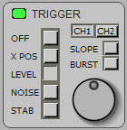
This panel is part of the Oscilloscope section is only used with the WAVE BURST and analysis.

The trigger point is represented by an arrow on the display pointing up or down depending on the condition of SLOPE, which moves to the right and to the left with XPOS and in upward or downward with LEVEL.

When the INPUT is OFF in the arrow moves down and indicates the zero point of the stored signals of time.

LED It lights up if the TRIGGER (synchronizer) acts.

OFF The TRIGGER is disabled, and the waveform is presented continuously.

XPOS The knob adjusts the position of the point of TRIGGER from left to right of the display.

LEVEL The knob adjusts the position of the point of TRIGGER in upward or downward with respect to the zero position of the selected channel for the trigger.

NOISE The knob adjusts the amount of noise tolerated by the TRIGGER (adjust to obtain the maximum stability of the waveform).

STAB The knob adjusts the maximum difference between a display and the next (regular in order to obtain maximum stability of the waveform).

CH1 The TRIGGER uses the signals from channel 1.

CH2 The TRIGGER uses the signals from channel 2.

SLOPE Select the trigger on the rising edge or on the front of the signal down.

BURST Special operation to synchronize signals consist of pulse packets.

Special measures

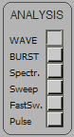
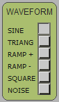

The ANALISIS panels, WAVEFORM, SETTINGS and SPECTRUM, all located on the right side of the instrument, enable the special measurement functions not found in a simple oscilloscope.

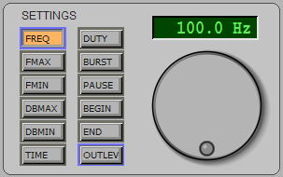

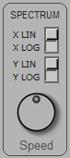

Signal generator (WAVEFORM)

It is available a generator of audio signals from 0.1 Hz to 22 KHz with six types of waveform including white noise and with possibility of burst (pulse packets).

Spectrum analysis (Spectr.)

It allows to analyze a signal by dividing it into various components with respect to the frequency. This function can also be displayed in three dimensions (amplitude, frequency and time) by selecting Spectrum3D from the VIEW menu. The spectrum analysis used with the noise generator NOISE can measure the frequency response by canceling the effects of resonance but suffers very randomness of the noise and does not provide very precise measurements.

type SWEEP Analysis

It allows to measure the frequency response with the SWEEP method (scanning frequencies over time with sinusoidal waves). The SWEEP is a rather slow but very precise method, however, is affected by the resonance effects of the devices under test and the environment in which the measurement is made. With reference calibration you can get to an accuracy of a tenth of a decibel.

The FAST-SWEEP and PULSE analysis

These methods measure the frequency response quickly and accurately. The analysis is carried out with very short pulses that contain in equal measure all frequencies of the audio spectrum. The pulses from the filtered in analysis components are divided in frequency and is achieved in one fell swoop the entire spectrum. Also, if you start sampling immediately prior to the pulse arrival and ceases to be sampled before they arrive unwanted signals due to reflections in the environment can be excluded resonance and reflection phenomena.

The measurement must be carried out in a quiet environment and preferably with a microphone and a low-noise input preamplifier, the method is sensitive to periodic disturbances (eg mains interference).

All these factors mean that noise measurement dynamic is quite limited, and that the noise tends to distort the measurements especially in the lower part of the spectrum (below one hundred hertz).
When making measurements with FastSweep Pulse and check that the noise is enough below the curve displayed by putting OUTPUT OFF position, otherwise raise, if possible, the output level to overcome the background noise. To perform measurements on speakers is good to use a rather powerful external amplifier.

To partially overcome the abovementioned problems the DAA analyzer provides two FastSweep and Pulse optimized methods respectively for the upper and lower parts of the spectrum.

FastSweep uses a pulse that contains equal energy all frequencies and is affected by the effects of noise especially in the lower part of the spectrum.

Pulse uses a pulse sawtooth that starts steeply up to the maximum value and then with linear trend tends to zero, a pulse of this type contains much more energy at low frequencies and this disparity is compensated for during the analysis of the spectrum, Pulse affected by noise in the high part of the spectrum.

The method used to perform the spectrum analysis is the FHT Fast Hartley Transform that is faster and more accurate than FFT Fast Fourier Transform. All of fast processing methods are inherently linear nature and to get a logarithmic scale ranging reconverted before being displayed.

Depending on the minimum and maximum frequency analysis of the Hartley transform is performed on 1024, 2048, 4096, 8192 or 18384 samples. If you select a minimum frequency below 50 Hz, the logarithmic scale X or X scale expanded very slightly slows down the speed of analysis.

For all types of spectrum analysis you can use the cursor Cursor 1 of the meter panel to measure with greater accuracy.

Mixer Settings

For all the measures it is necessary that the controls BASS and TREBLE of MIXER are centrally located and 3Dstereo that the command is enabled. If you want to use these commands (for example, to evaluate their effectiveness) you have to keep the output volume to about twenty decibels below the maximum to avoid that distort the sound card output.

Some distort sound cards when they work with the maximum output voltage and 'always good do not keep up the WAVE slider output level of the mixer output. Sometimes' well even lower level of DAA OutLev one or two decibels.
Check with a sine wave and the spectrum analyzer with the level of harmonics and spurious which should be at least 80 decibels below the fundamental.

The Analysis panel

With the ANALYSIS panel determines the basic configuration of the analyzer.

WAVE Oscilloscope and signal generator.

BURST Showing oscilloscope type and signal generator to BURST (pulse package)
The number of cycles that make up the package and the pause between packets is set by SETTING - BURST and PAUSE.
This type of analysis is often used to highlight the resonance due to queues insufficient damping of speakers.

Spectr Spectrum analysis.
The measuring scale is adjustable with SETTINGS - FMAX, FMIN, DBMAX, DBMIN.
The type of scale is selected by SPECTRUM XLIN/XLOG and YLIN/YLOG.
The response speed is adjusted with SPECTRUM - Speed.
The spectrum can also be displayed in three dimensions (amplitude, frequency and time) by selecting Spectrum3D from the VIEW menu.

Sweep Spectrum analysis in frequency sweep with a sinusoidal generator.
Remember to place the ON INPUT and OUTPUT MONO position or location STEREO and select SINE WAVEFORM position.
The scanning time is adjustable with SETTINGS - TIME.
The measuring scale is adjustable with SETTINGS - FMAX, FMIN, DBMAX, DBMIN.
The type of scale is selected by SPECTRUM XLIN/XLOG and YLIN/YLOG.

FastSweep impulsive Analysis of the frequency response optimized for maximum dynamic
(Minimum noise) on the upper part of the spectrum.
The measuring scale is adjustable with SETTINGS - FMAX, FMIN, DBMAX, DBMIN.
The type of scale is selected by SPECTRUM XLIN/XLOG and YLIN/YLOG.
The response speed is adjusted with SPECTRUM - Speed.

Pulse impulsive Analysis of the frequency response optimized for maximum dynamic
(Minimum noise) on the lower part of the spectrum.
The measuring scale is adjustable with SETTINGS - FMAX, FMIN, DBMAX, DBMIN.
The type of scale is selected by SPECTRUM XLIN/XLOG and YLIN/YLOG.
The response speed is adjusted with SPECTRUM - Speed.

The Waveform panel

With this panel will select the waveform of the signal generator.

SINE Sine wave.

TRIANG Triangular wave.

RAMP+ Wave positive ramp.

RAMP- Negative ramp wave.

SQUARE Square wave.

NOISE White noise.

These waveforms are obtained only if OUTPUT is ON and if ANALISIS is in position WAVE, BURST or Spectr.

The Settings panel

The panel is composed of a selection keyboard and a knob and a display to adjust and display the selected value.

I pressed buttons are highlighted in orange. Those assets are trimmed in blue.

DISPLAY Show the selected value.
Click on the display with the left mouse button to edit the value, then press ENTER key or click on the knob to confirm the value.

KNOB Regulation for all the values, this knob which acts with an effect proportional to the speed
of rotation allows rapid changes but also fine adjustments.

FREQ Frequency of the signals generated from 1 Hz to 22 KHz.

FMAX Minimum viewing frequency from 1 Hz to 22 KHz
(SWEEP, SPECTRUM and PULSE). FMAX can not fall below FMIN.

FMIN Maximum viewing frequency from 1 Hz to 22 KHz
(SWEEP, SPECTRUM and PULSE) FMIN can not exceed FMAX.

DBMAX Upper limit of the scale from -90 dB to +10 dB (SPECTRUM, SWEEP and PULSE).
Near Dbmax can not fall below DBMIN.

DBMIN Low limit of the scale from -120 dB to +10 dB (SPECTRUM, SWEEP and PULSE).
DBMIN not exceed near Dbmax.

TIME Duration of scan in seconds (SWEEP).
Use a long time to make more precise the lower part of the frequency spectrum.

DUTY pulse / space ratio for the square wave (SQUARE).

BURST Number of cycles that make up the pulse packet (BURST).

PAUSE Number of cycles that make the break between the pulse packets (BURST).

BEGIN Beginning of sampling (for FastSweep and Pulse only).
This value is rather difficult to adjust (see Notes Begin - End) if you do not know how adjust to keep it to a minimum, ie to zero.

END End of sampling (pears only Pulse).
This value is rather difficult to adjust (see Notes to Begin - End) if you do not know how adjust keep the maximum value, ie to 200mS.

OUTLEV Output level for the signal generator and for the Sweep pulses, FastSweep and Pulse.
The usefulness of the output level is to make small precise changes to the tenth of a decibel They are not possible with the Windows Mixer.

The Spectrum panel

Scale Settings for: Sweep, Spectr, PulseLo and PulseHi.

XLIN Frequency scale (linear axis X).

XLOG Scale frequency (X-axis) logarithmically.

YLIN Scale of the amplitudes (Y linear axis).
The linear scale is calibrated in volts.

YLOG Scale of the amplitudes (Y axis) logarithmically.
The logarithmic scale is calibrated in decibels (referenced to 2 volts peak-to-peak)

Speed Rapid response of the display.
Speed adjusting to a low value (counterclockwise) is carried out the average over a long time improving the measuring accuracy and decreasing the noise.

The Menu bar

The menu bar allows you to access files and to choose global features and configurations related to the whole application.

The last two menu items, related to audio inputs and outputs, vary depending on the sound card and operating system language.

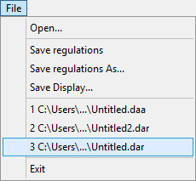
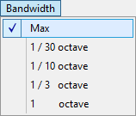
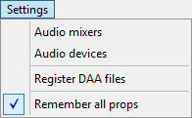

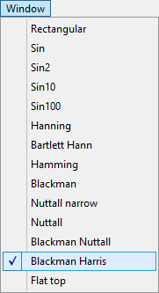
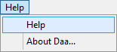

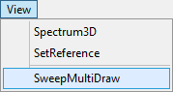
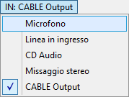

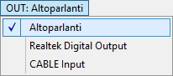

On the following pages the menus are explained one by one.

The File menu
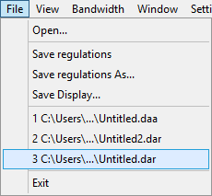

Open Read the DAA files.
All analyzer settings are present in the DAA files therefore you can quickly restore a configuration prepared and saved earlier.

Save Regulations Save the analyzer status on the currently selected DAA file.
The current file name is visible in the title bar (top left).
If no file name is selected then a Save Dialog will ask for it.

Save Regulat. As... Save the analyzer status of a selected file or a new file.

Save Display Save the image on the display in BITMAP format.

Files List The recently used files.

Exit To exit the DAA program.

The View menu

Spectrum3D Displays the spectrum analysis in three dimensions (amplitude, frequency and time).

SetReference Freeze the shape of this waveform on the screen to use as a comparison and reference.

SweepMultiDraw Only it used with the SWEEP analyzes.
Press the right mouse button to start a new sweep.
The previous sweep are not deleted.

The Bandwidth menu

Selects the bandwidth for SPECTRUM and PULSE analysis.

The Window menu

Selects the sampling window for SPECTRUM analysis.

The Settings menu

Audio mixers - Opens mixer listening audio (output) and record (input)

Audio devices - Opens the control panel for the audio devices configuration.

Register DAA files - With this command you register DAA files to open them with a double click with this application.

If you move the DAA application, or change its name to its folder, the operating system can no longer associate DAA files with the application. Instead this command always succeeds.

Remember all props - Enabling this option all the settings are remembered also by closing the application. To restore the basic settings, deselect this option and then close and restart the DAA application.

The Help menu

Help - Opens the folder containing the documentation files.

About - Provides information on the DAA program.

The Input Devices menu

With this menu you choose the input device.

The number of items that appear depends on the sound card.

Some devices may not appear because they are disabled. With the AudioDevices menu you can view hidden devices and enable them.

The Output Devices menu

With this menu you choose the output device.

The number of items that appear depends on the sound card.

Some devices may not appear because they are disabled. With the AudioDevices menu you can view hidden devices and enable them.

The Begin-End controls

By choosing a sampling window that begins when the impulse is to reach the microphone and ends before they reach the reflections on the walls of the environment you get a higher precision for FastSweep and Pulse analysis. These values must, however, be adjusted with otherwise cognition can completely distort the measurement.

BEGIN

usually BEGIN and 'to zero, the automatic synchronism places the beginning of the sampling just before the' beginning of the pulse to be analyzed. Sometimes, however, 'the synchronism does not act well and is' necessary to make a small manual corrections by BEGIN.

If BEGIN is exceeded, even slightly, the pulse start this is truncated, and the frequency response changes so completely an adjustment mode can be arriving until the response changes and then go back a little.

The most accurate method to adjust BEGIN however, is the following:
- Press the SAMPLES button.
- Set the TIME BASE knob at 1mS/Div, raise mV/Div of one up to frame good channel pulse start
- Adjust BEGIN to bring the surge began about a division of the TRIGGER on the right arrow.
- Also check that the pulse width is less than one volt (see VIEW Menu - ViewSamples).

END

The END adjustment only with PULSE type analysis,

Normally the END value is left at maximum (200 mS) but it is possible to decrease it to truncate the sampling so as to exclude reflections on the walls of the room.

Adjust END to the distance between the speaker and the nearest opposite wall or side of the chest, plus the distance between this wall and the microphone.

If the environment is small and therefore the distance is low you lose precision on the low part of the spectrum and it is better to adjust END on a higher value even if doing so includes a part of the reflections.

The END and 'measured in milliseconds value but while it regulates and' can see in the bottom (status bar) the converted value in "meters traveled by the sound".

On the status it can 'bar also read the minimum valid frequency which is continuously recalculated and is visible until the mouse cursor remains positioned on the knob.

Frequency Response measurements

To perform frequency response measurements of acoustic systems (loudspeakers) is necessary to use a microphone. The microphone must have a sufficiently flat frequency response are therefore excluded from the dynamic microphones.

A great microphone for these measures is the electret type that is readily available commercially.

The best electret microphones ensure a frequency response within a decibel from 20 Hz to 20 KHz (do not use models with three-wire or with an outer diameter of 10..12 mm. Using the model to two terminals with a diameter of 6 mm).

The electret microphones need a source of direct current (5..10 volts in series with a resistor 4..10 K) that is usually already arranged on the incoming MIC sound cards (only if the MIC input is not stereo).

To connect the electret microphones to the MIC use a stereo jack with two signal heads (right and left) joined (one of the heads provides power and the other carries the signal), and a shielded cable, not longer three meters, with stocking and only one signal wire. (Check on the arrivals feeding microphone, from 1 to about 3 volts)

Using a microphone preamplifier

If the power supply is not available, he wanted to use a connection wire is longer or requires greater sensitivity you will have to use an external preamplifier with power stack that greatly facilitate the measurements.

The external preamplifier advantages are:
- Greater and adjustable sensitivity
- Low noise and elimination of cable noises
- Very low output impedance which allows to use a long cable up to 10..50 meters.

The external preamplifier must be connected to the LINE (not MIC).

The shielded cable must stand between the preamplifier and the input LINE and not between the
microphone and preamplifier which must instead be close, with a short and well shielded connection.

What type of preamplifier

The preamplifier without battery be enough if you work with moderate sound pressure but must be careful because it could easily saturate (check with the "SAMPLES" button).

For professional use in all conditions it is better to use the version with battery.

To further increase the tolerance to high sound pressures (concert plants) it is possible to increase the battery voltage up to thirty volts, replacing C1 with a 35volt capacitor, and increase R1 up to about 39K. Then measure the voltage on the "Test Point" and replace R1 to obtain the half of the supply voltage.

Preamplifier with battery
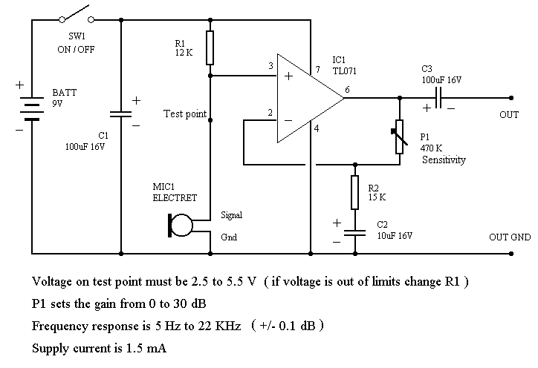

Disposition of the components
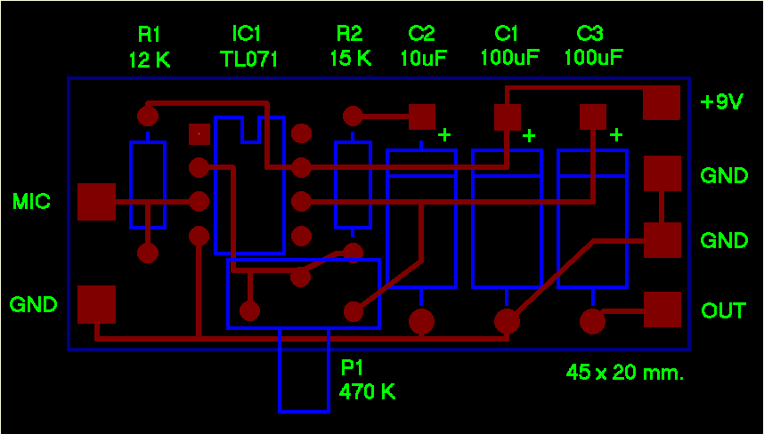

A pre-amplified microphone without battery

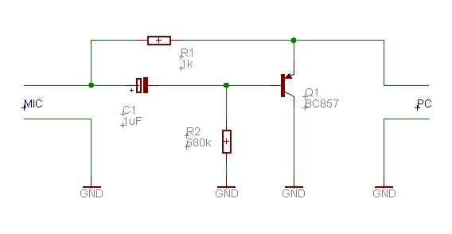
To avoid the hassle of having to periodically change the battery and also to avoid the clutter and the mechanical complications due to the holder, there is a very convenient solution, but that is not found in commerce. Who was able to do small works of electronics could build it.

Features :

Gain 12 dB
(Minimum 8, maximum 14 depending on the sound card)

Noise of very low down
(Indistinguishable from the noise of the microphone bottom itself)

Frequency range from 10Hz to 100KHz

The components are not critical, instead of BC857 you can use a BC307 or any other PNP small signal.

E 'can make a small assembly in the air or you can make a printed circuit board with double-sided vetronite. On the lower face, which is not 'visible here, the copper must be a continuous plane.

On the left is steady the microphone (an electret microphone 6mm) with the negative on the lower face and the positive on the junction of the resistor and the capacitor.

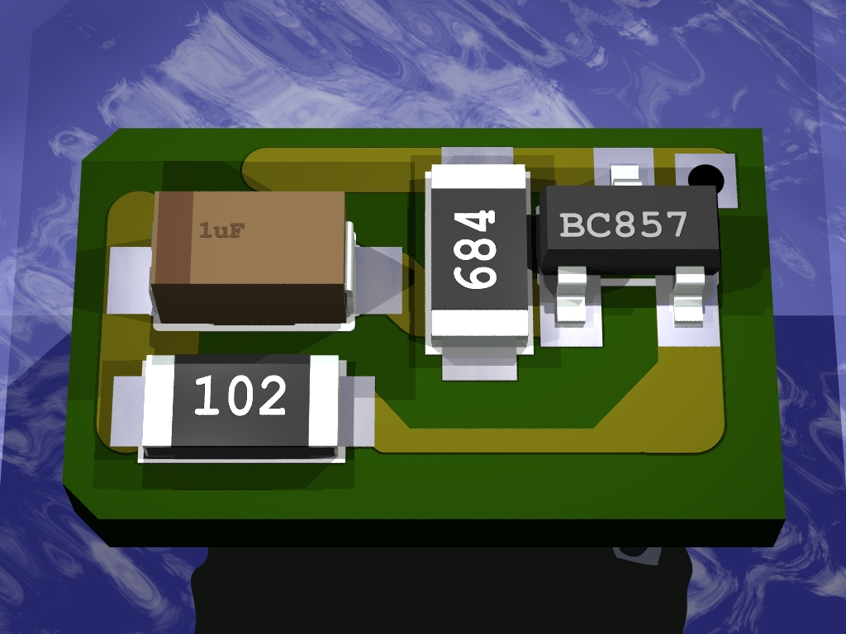

In this hole is inserted a small wire diameter and is welded above and below.

From here the shielded cable going to the PC. It must be welded to the copper cable sheathing on the lower face and the central wire to the triangular pitch.

(Dimensions 6 x11 mm)

If you want to eliminate any possibility of noise and hum and well enclose the whole (including the microphone and the stripped end portion of the shielded cable) in a copper tube 6mm inner diameter, a few centimeters long, and solder the wire to this tube and that 'soldered to the printed hole.

Advice on the microphone positioning

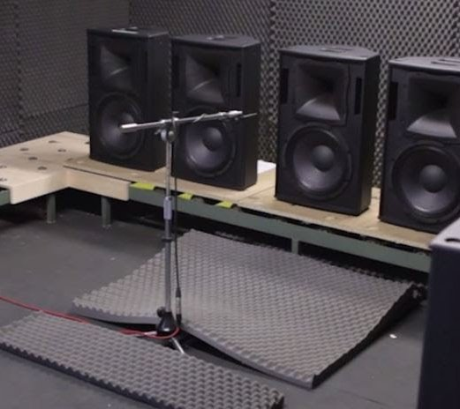

Various methods are used to measure the response curve of the boxes, without having any inaccuracies due to the reflections.

First method
Place the box outdoors, lying down with the cones pointing upwards, and the microphone hanging one meter in height (inexpensive but also very inconvenient).

Second method
Use an anechoic chamber.

Third method ("Begin" and "End")
Begin and End can only be used if you work in a very large environment (disco) where the nearest wall is over ten meters.
The microphone is placed a few meters from the speaker. Only one speaker is lit at a time otherwise they interfere with each other and ruin the measurements. "Begin" is set so as not to cut off the first part of the "End" impulse is set to double of the distance from the nearest wall. This "double" must be at least 20..25 meters otherwise the bass is measured badly. This way the sampling window excludes the reflections because they arrive too late and when the measure is reached now made.

Fourth method
Keep the microphone very close to the speakers, it is the most comfortable and, in some ways, even the most accurate as long as you do a little testing so you understand well what you are measuring and do not take dazzle.
With the microphone at 5.50 cm from the cones (depending on the size of the speakers and the room) the difference in sound pressure between the direct and the reflected sound is so high that the reflections do not affect almost the measurements.
With not more than 5 centimeters errors are certainly less than a decibel.
However, in doing so, you must measure the cones one at a time by placing the microphone exactly on the axis in front of the cone (at the same distance for all the cones).
It ends up so to have three separate curves (or two or four depending on the number of ways) curves to be evaluated separately, in order to understand the flatness and the peaks and holes of each band.
Then the microphone is moved away to a meter (on the axis - in the middle of the box) and, neglecting this time the peaks and the holes that will surely be increased, focuses on the average level of the bands that must be as similar as possible.
The fourth method may seem imprecise and insecure, but when you take your hand, it is the best, even the most accurate of the anechoic chamber.
The next page explains other details of this method.

Operation of the fourth method

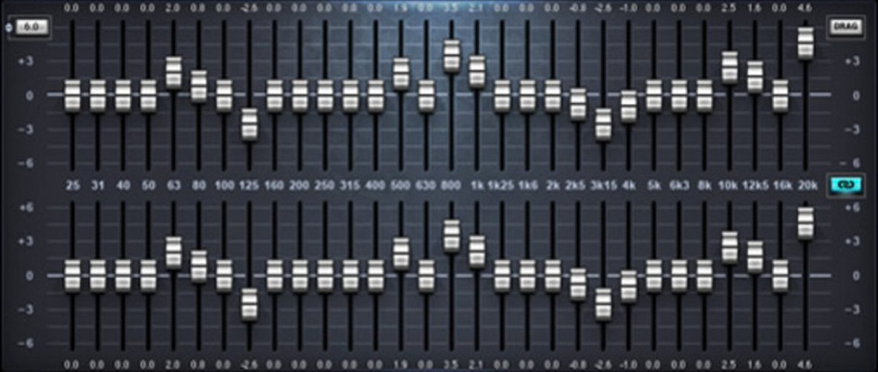
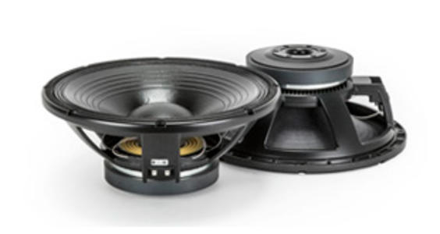
If you place the microphone on a meter-by-case basis (classic measurement in an anechoic chamber), you will find peaks and holes (especially in the crossover frequency zones) that are due to the microphone-tweeter, microphone-midrange and microphone-woofer distances.

There are interferences characteristic for that particular position of the microphone that change completely if you move the microphone (even 5 or 10 dB for a movement of 50 centimeters to the right or left, backwards or upwards, etc.)

These peaks, caused by interference, have nothing to do with the environment, reverberating or not, and all the speakers with more than one cone, even the most expensive, even in an anechoic chamber, create peaks and valleys at certain frequencies, that change at depending on the distance and position of the microphone.

It is an unavoidable physical phenomenon, in some particular positions and particular frequencies the pressures add up or cancel each other out. There is no remedy unless you have all the sources at one point, even the cones with the coaxial tweeter are not exempt (due to those two centimeters away), you should just use a single cone... and you can not .

Ultimately, if you try to measure the whole case you will always find peaks and valleys (even of 10 dB) that confuse the measures and do not center anything with the characteristics of the cones, crates and crossovers.

The builders of coffers know this and always make sure to reduce as much as possible the inaccuracies that are measured at one meter, in axis. Too bad that usually the speakers listen to more distance and almost always off-axis.

This is not to say that at three meters the boxes will be worse, but that you should not fix yourself to measure and correct the holes and the peaks due to interference (so each listening point will have them different). And be careful not to lose hours with the equalizers to get a perfect equalization that will then be valid only at the exact point where the microphone is positioned.

We could measure the answer in, say, ten or twenty different positions randomly spaced across the listening area and then averaging...

But the best thing would be to have an instrument that do not see these interferences, and, indeed, this is precisely what we get if we measure the cones one by one at a short distance and in axis.

Finally, you move the microphone at more distance. You pretend that peaks and valleys do not exist and equalize the cones emissions by adjusting the gain of each band.

Technical features

The DAA 5224 and 'a measuring instrument and test equipment for audio with high precision.

The instrument comprises the following functional blocks:
- Signal viewer
- Signal generator
- Sampler
- Frequency meter
- Analyzer

Viewer (as oscilloscope)
- Amplitude adjustable from 1 mV / div to 1 V / div
- Time base from 100 sec/div to 100 us/div
- Trigger positive or negative
- Triggers for pulsed signals
- Level control for manual trigger
- Two tracks, addition, subtraction and display X/Y.
- A width of the track position.
- Visualization with delay and DeltaTime.
- Storage of the last ten seconds at full resolution.
- Automatic calibration of the DC offset.

Viewer (as a spectrum analyzer)
- X-axis linear or logarithmic with minimum and maximum frequency adjustment.
- Axis Y linear with maximum amplitude adjustment from 1 Veff to 1 mVeff
- Y logarimic with maximum amplitude adjustment from + 10 dB to -90 dB
- Y logarimic with minimum amplitude adjustment from 0 dB to -120 dB

Viewer (as three-dimensional spectrum analyzer)
- X axis and Y as spectrum analysis
- Z axis with time adjustment.

Signal generator
- Frequency range: 1 Hz to 22 kHz in steps of 0.1 Hz.
- Waveforms: Sine / Square / Triangular / Ramp positive / Ramp negative / White Noise / Burst / Special pulses for frequency response measurements.
- Adjusting the duty cycle: 10 to 90% in steps of 0.001%
- Distortion less than 0.002%
- Noise less than -96 dB
- Stability and accuracy better than +/- 0.0001 Hz and one part in 200,000, equal to 0.0005%

Sampler
- Frequency range: 0.1 Hz to 22 Khz
- Noise less than -96 dB

Frequency Meter
- Measurement of frequencies from 0.1 Hz to 22 Khz with an accuracy of 0.001 Hz.
- Measures of time from 1 second to 100 us with precision 50uS

Analyzer
- Measurements of amplitude in dB and in volts.
- Measurements of timing and frequency offsets.
- Sliders measurement.

Frequency Precision characteristics

With a good sound card the accuracy of measurements of time and frequency is better than one part in a million.

Some sound cards, in particular conditions, can be very inaccurate in the sampling frequency. So it is good to check your card with a known precise source (not the 50Hz).

Note also that if the sound card is used simultaneously by the DAA and one or more other audio applications the frequency accuracy can, in some cases, deteriorate considerably.

In the event that two applications use different sample rates some sound card privilege the first application, and perform subsequent applications with an approximate sampling rate (in some cases even errors of one percent).

Other characteristics

Some sound cards have an artificial system enlargement of the distance between the speakers (3d stereo enhancement), make sure it is disabled otherwise the frequency response is disturbed.

Also make sure that the tone controls are inactive.

Some notebooks have an ever-present equalizer to enhance the sound of their small speakers, often, but not always, you get a flat response when you insert a jack on the audio output. Sometimes it can 'be necessary to power cycle the audio out' cause the jack is detected.

Depending on the used sound card, and as it is physically installed in the computer and of the shielding characteristics of the computer, noises may be present noise components outside the audio range (50 Khz - 200 Mhz) also of considerable amplitude.

These noises, which usually do not cause problems in audio measurements, could be eliminated using connection cables that incorporate a low-pass filter.

How to see the output signal

In rare cases this may 'happen that the audio card might not support the possibility to set as input the output signal generated by herself.

In these cases, you must put a wire (stereo jack) between the output "LINE OUT" and the "LINE IN input" or "MIC IN".

On notebooks it is always good to put a jack in "LINE OUT" so that the sound card excludes the internal speakers, so the internal equalizer which serves to make them sound a bit better, thus obtaining a flat frequency response that is important for the measurements.

