System theremino
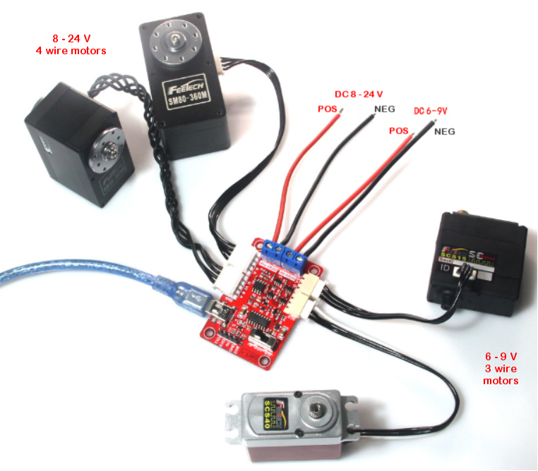
Program
FeeTech motors

Program the FeeTech motors

FeeTech servo motors connect to a serial line of type Half-Duplex (the line can be RS485 with two balanced wires, or TTL with a single wire).

The devices are connected in a chain by means of a four-wire cable (two signals plus power supply and GND) or even just three wires in the TTL version.
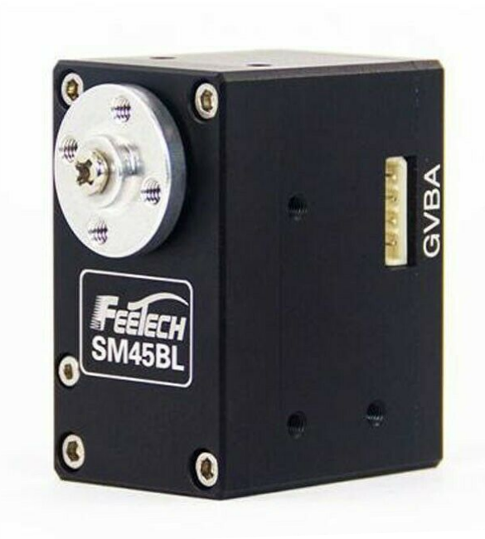
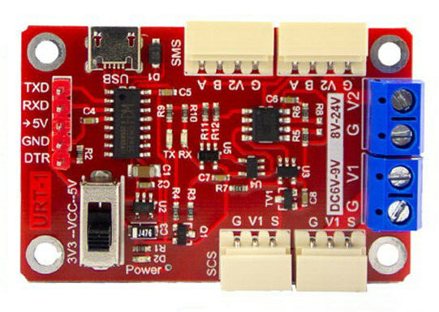

These servo-motors, also called Robot-Motor or Smart-Motor, contain all the control electronics, a 4096 step encoder and a configurable PID algorithm that allows to control the rotation with 0.09 degrees precision.

You can also adjust the speed, acceleration and torque, as well as read the position reached, the temperature, the current (which is related to the torque) and many other parameters.
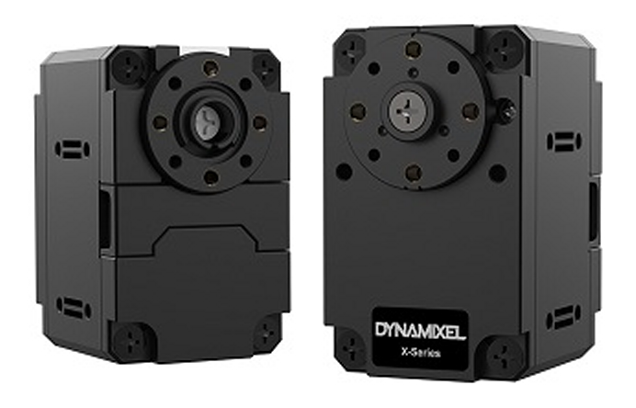
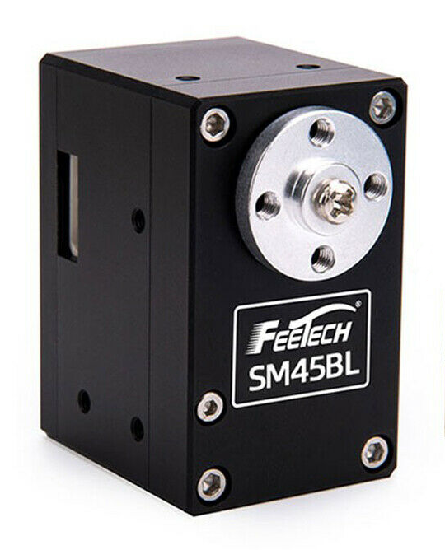

Some Dynamixel motors can be controlled in a range of +/- 256 rpm, while currently the FeeTechs (Note 1) they have a smaller range, of only +/- 7.5 turns.

(Note 1) Two models from FeeTech are in preparation with true torque control and position control in a practically infinite range. True SmartMotors for industrial controls but at a highly competitive price.

Communication protocols

In this document we will use the abbreviation DXP1 which stands for: Dynamixel 1.0 a protocol that allows you to communicate with all servomotors Dynamixel is FeeTech.
There is also a protocol Dynamixel 2.0but we didn't implement it because it would only work with some Dynamixel models (MX and PRO) and with none of the FeeTechs. Furthermore, the 2.0 protocol does not contain any particular advantages. Its only major improvement would be the SyncRead instruction, which is superseded by our implementation ofBuffered transfers

Use the DXP1 and Modbus protocols
FeeTech servos can be programmed to use either the DXP1 protocol or the ModBus protocol. The latter is familiar to PLC users, but has lower speed performance and fewer commands.
To use DXP1 and Modbus devices we have written two applications that are called Theremino_RS485 is Theremino_Modbus On their pages you will also find the related documentation files.

Program FeeTech servo motors for DXP1 or Modbus
In the ZIP archive that you download from This Page you will find everything you need to reprogram FeeTech servos with the two protocols.

To reprogram the FeeTech motors you will need a USB connection module, like the one in the image on the right, a USB cable and a connection cable for the motors.
You will also need a 6 or 24 volt power supply, which connects with the negative to terminal "G" and with the positive to V1 or V2.

The power supply must have a convenient power switch located near the PC keyboard and the Mouse. With the switch you have to give power exactly at the same time you press the programming button on the software. If this action is not done synchronously, the programming will not start.

USB and serial connectors

To connect the motors to a PC, the USB connector shown at the top of this image is used.

This module could also be connected to an Arduino by means of a serial link.

To connect an Arduino you would use the serial connector located on the left side of the board. Butto program the motors this connector is not used and must necessarily be connected via USB.

The switch that you see at the bottom left is only needed if you connect an Arduino and in that case it must be positioned on the 3V3 or 5V side, depending on the type of Arduino. Butwhen programming motors via USB the position of this switch does not matter.

Connect the motor and power supply

The four-wire motors are connected on this side and are powered with the connector marked 8 .. 24 V
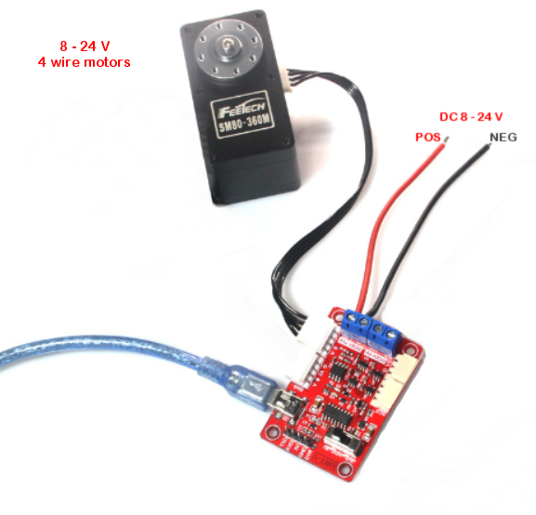
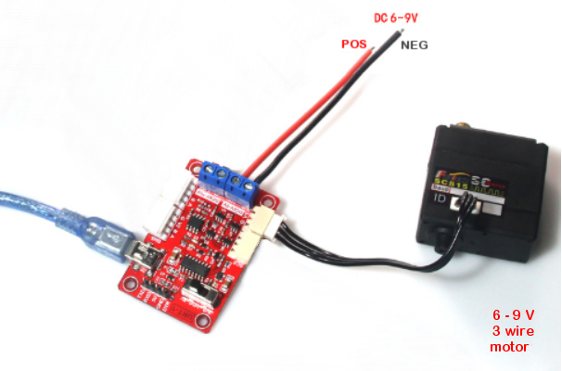
The three-wire motors are connected on the opposite side and are powered by the connector marked 6 .. 9 V
Check the COM port

Disconnect the USB cable
Open the "Com" box and look at the port names
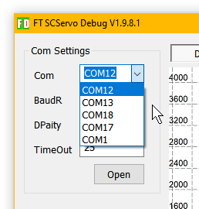

Connect the USB cable
Close and reopen the "Com" box to locate the new port.

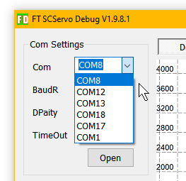
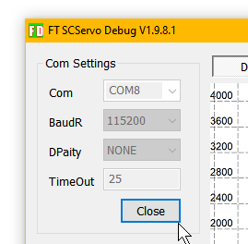
In this case the port was COM8 but if the list of ports remains the same, both with the USB cable and without the USB cable, then you will have to install the CH340 driver and then repeat the instructions on this page.

The file to install the CH340 driver is in the same ZIP that contains these instructions and is called: "CH34x_Install_Windows_v3_4.EXE"

Upload the firmware file

To write the firmware in the engine first of all you have to load it from disk.

You start by pressing the "Upgrade" button
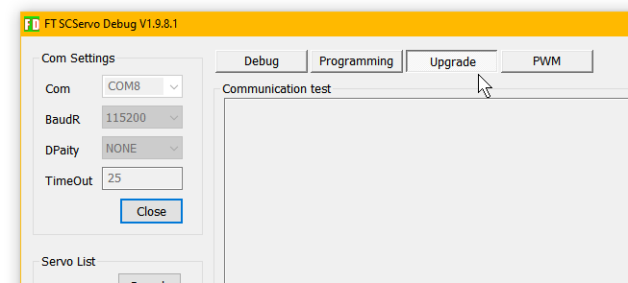
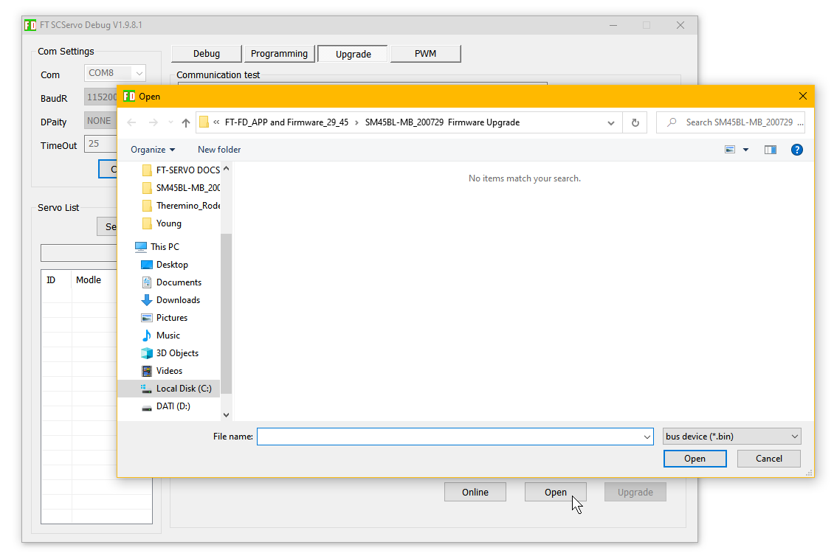
Then you will have to press the "Open" button which opens the window to upload the files.

Choose the folder and file

The ZIP file that contains this documentation must be unzipped, and in the resulting folder there should be four folders containing the firmware files and programming values ​​files.

The folder names start with SM29 or SM45 depending on the motor to be programmed:

- SM29BL-191220 firmware upgrade
- SM29BL-MB_200729 Firmware Upgrade
- SM45BL-191220 firmware upgrade
- SM45BL-MB_200729 Firmware Upgrade

The folders containing the letters "MB" contain the files to program with the ModBus protocol, while the other two are used to program with the RS485 protocol.

Once you open the right folder you should see files with the extension .bin or .mbin

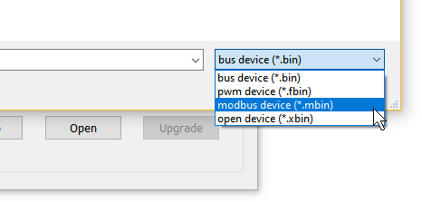

If you do not see the file in the folder then you will need to open the file types box and choose the right type, .mbin for ModBus or .bin for RS485
Write the firmware to the engine

Once you have loaded the right file to write it into the engine you must have the COM port open (see on the previous pages how to open it) and it must be programmed with speed 115200.

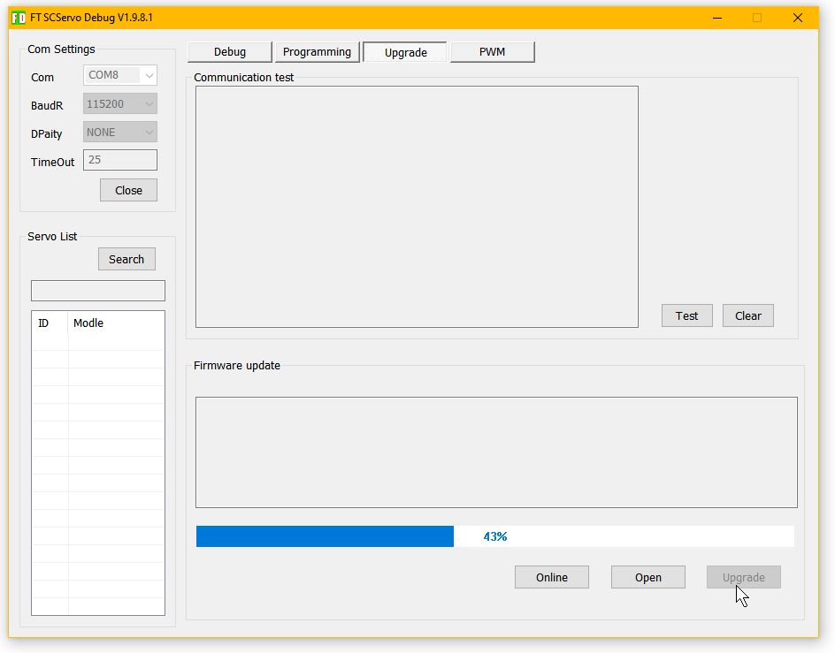

Then the motor power supply is turned off.

Finally, turn on the power supply and simultaneously press "Upgrade"

If everything is done right the blue bar will start growing and when it reaches 100% the engine is programmed.

At this point you could also go straight to the last page and try if the engine works, but usually the settings are also loaded from disk, to start with known values.

Change the set values

Selecting the motor in the list on the left (in this case SM45BLMD) opens the list of registers with the values ​​currently set.
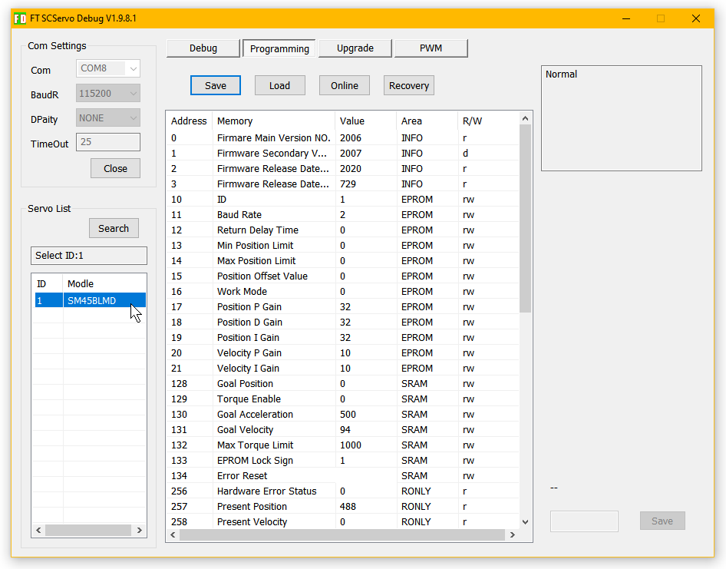

These values ​​can be changed manually, one at a time.

To modify them, select the row of one of the registers and its value will appear in the box at the bottom right, then modify the value and press "Save".

It is also possible to save all values ​​to disk or load all values ​​from a previously saved file, as we will see on the next page.

Load the settings

With the Save and Load buttons you can save all settings to a file or load them from a previously saved file.
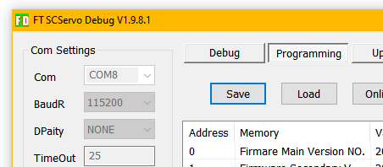

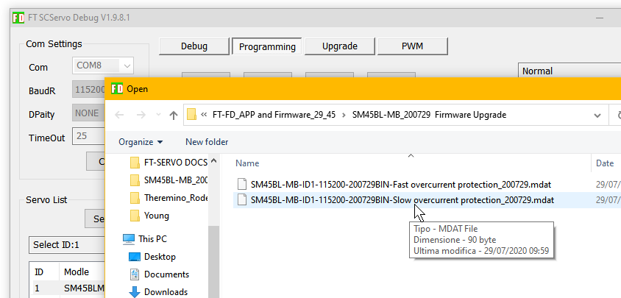
For example, pressing "Load" opens a window like the following that shows two files of settings.

If you choose the file, you press "Open" and all the parameters are loaded.

Check engine operation

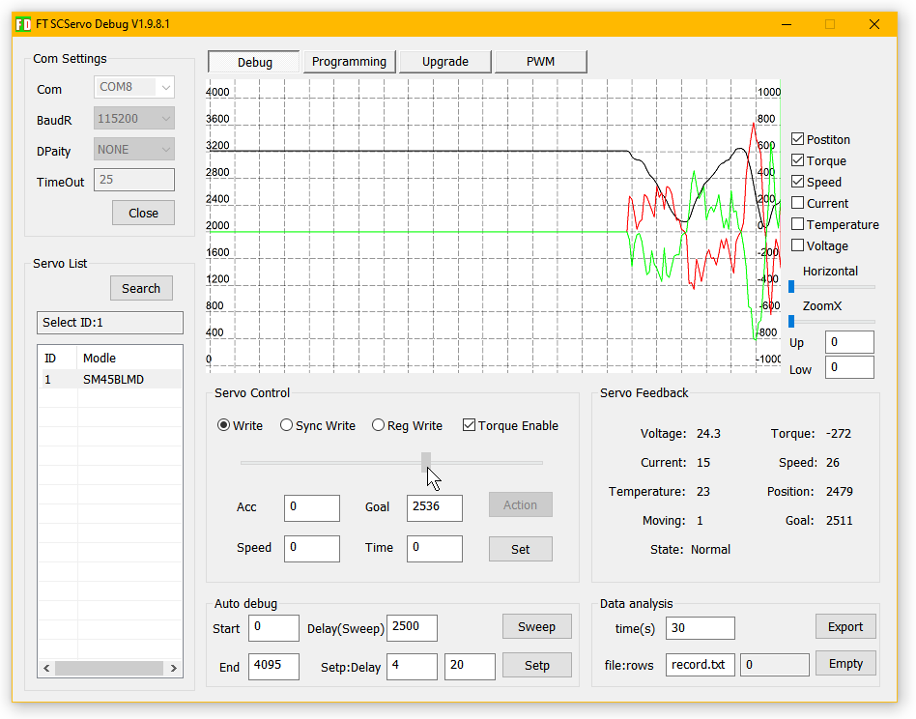
Finally, if all goes well, the motor should move by moving the cursor indicated with the arrow in the following image with the mouse.

To move the motor it is necessary that its name (in this case SM45BLMD) is selected in the white list on the left. Click with the mouse on the name.

Sometimes the motor may not move because the parameters set with the "Programming" menu have wrong values. For example, speed, acceleration or other motion-related parameters could be zero.

Then try putting 1000 in the "Speed" box. And then optionally select "Programming" and check the motion parameters.

If you really can't, you can reload all the parameters, as explained in the previous pages or even start these instructions from the beginning.

